Task 1 Questions What are the filenames and file sizes for each of the *.jpg pictures discovered in image_01.dd?

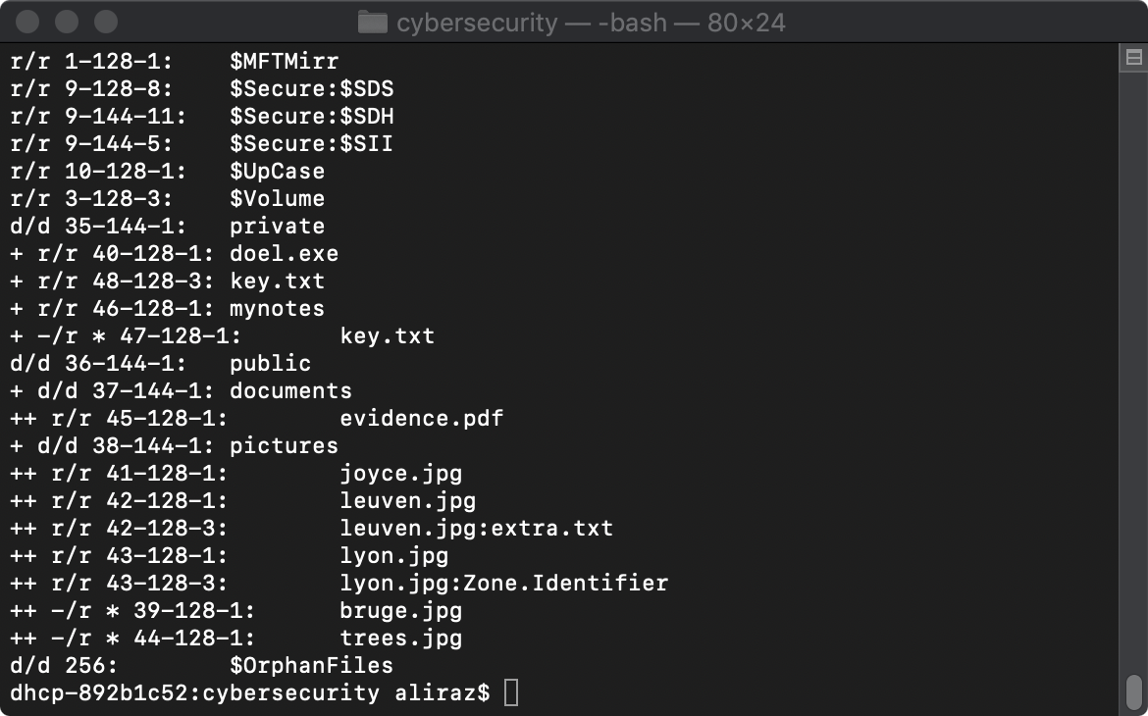

By using the **fls -o 61 -r image_01.dd** command we can find all of the file names including the jpg files

For finding the file size I extracted each one individually by icat command using the names found above.

E.g. icat –o 61 image_01.dd 39 > bruge.jpg

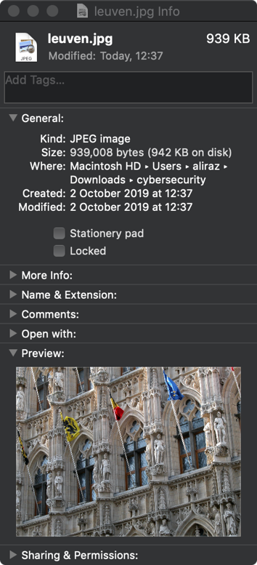

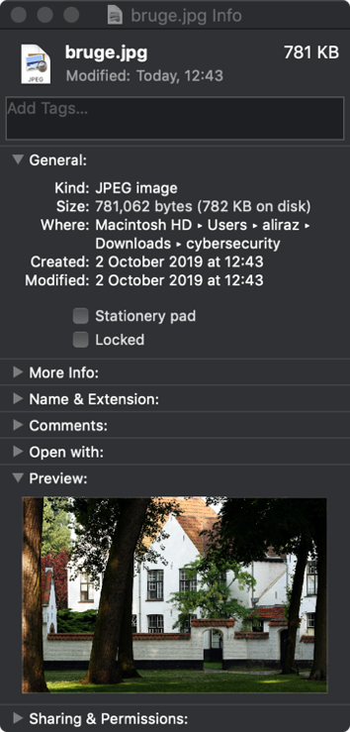

bruge.jpg has file size of 781 KB leuven.jpg has a file size of 939 KB

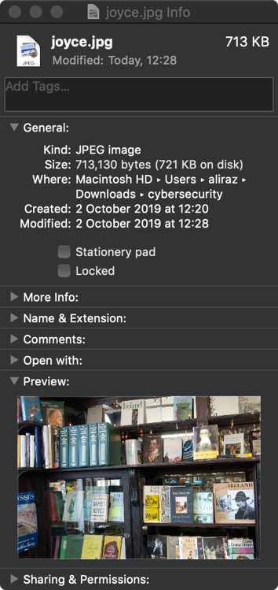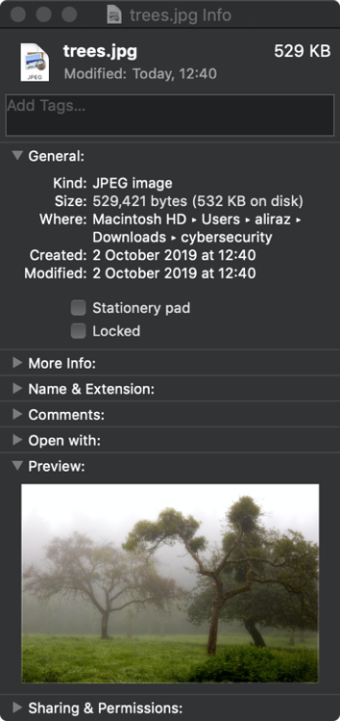

trees.jpg has file size of 529 KB joyce.jpg has a file size of 713 KB

Task 2 Questions What are the filenames and file sizes for each of the *.jpg photos discovered in image_01.dd using Photorec?

The name and the size of files that were extracted using photorec are shown in the screenshot below.

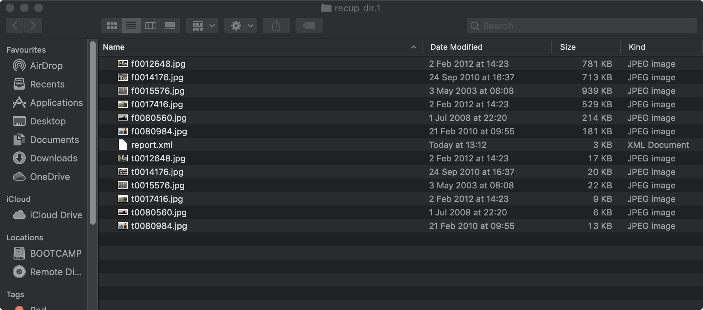

To extract photos automatically using Photorec. We first need to run the program.

For running the program, we have to write **photorec image_01.dd** in a terminal. Then we choose the proceed option at the bottom of the screen.

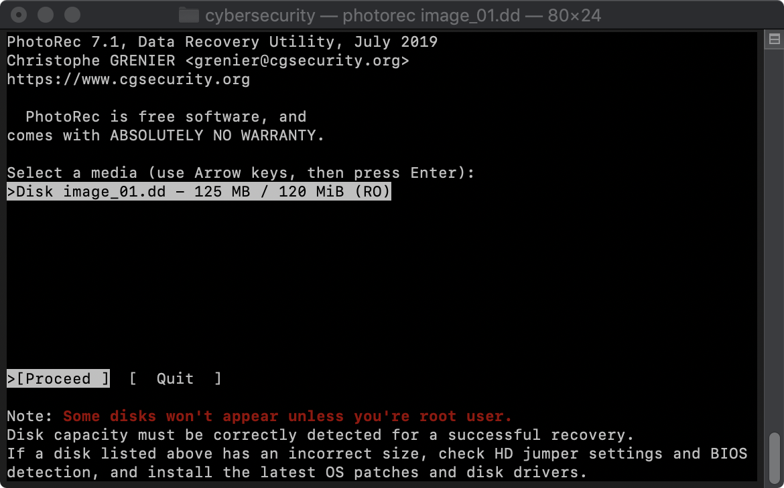

Then we have to deselect the type of files that we do not need. For that we choose “file opt”

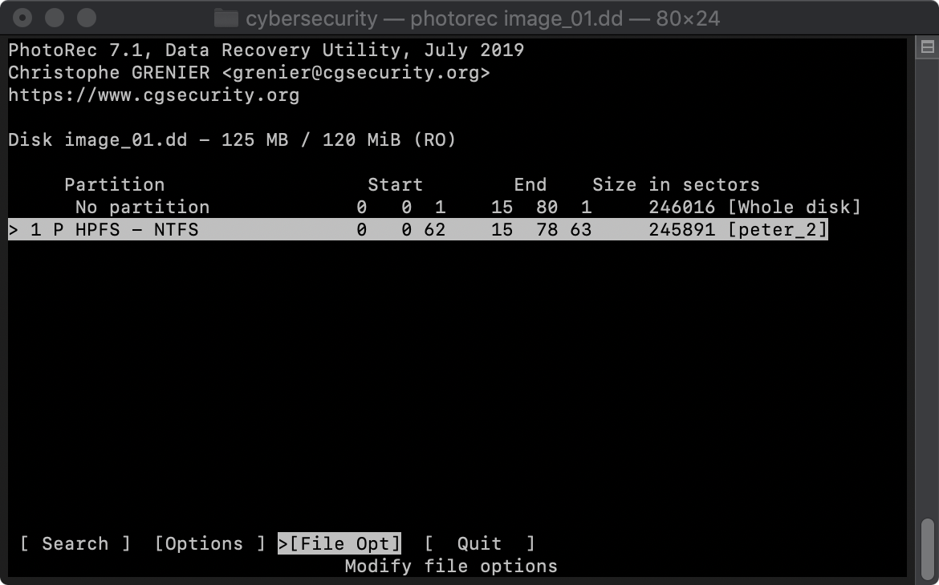

Then by pressing the ‘s’ we deselect all of the options and by going on jpg and pressing ‘x’ we select it and that is our desired file type. After we chose our options, we press b to save the new instructions.

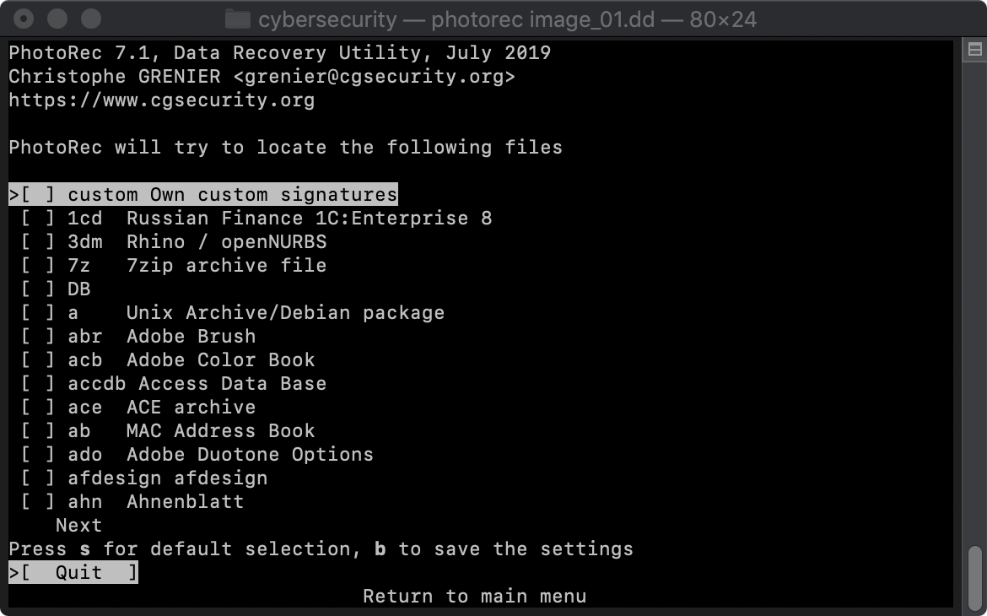

Afterwards we choose a location to extract the file to by pressing ‘c’ to confirm our location.

Include a full resolution copy of the extra photo discovered using Photorec in your Word Document (i.e. not recovered using sleuthkit)

